## B.M.S COLLEGE OF ENGINEERING BENGALURU

Autonomous Institute, Affiliated to VTU



OOMD Mini Project Report

## SMART DOCUMENT MANAGEMENT SYSTEM

*Submitted in partial fulfillment for the award of degree of*

Bachelor of Engineering in

Computer Science and Engineering

*Submitted by:*

## JYOTHIKA C.N. - 1BM21CS083

## KANJIKA SINGH - 1BM21CS086

## KAUSHIK POTLURI- 1BM21CS89

## KEERTHI REDDY - 1BM21CS090

Department of Computer Science and Engineering

B.M.S College of Engineering

Bull Temple Road, Basavanagudi, Bangalore 560 019 2023-2024

## B.M.S COLLEGE OF ENGINEERING DEPARTMENT OF COMPUTER SCIENCE AND ENGINEERING



***DECLARATION***

We, JYOTHIKA C.N. (1BM21CS083) ,KANJIKA SINGH (1BM21CS086), KAUSHIK POTLURI(1BM21CS89),KEERTHI REDDY (1BM21CS090) students of 6th Semester, B.E, Department of Computer Science and Engineering, BMS College of Engineering, Bangalore, hereby declare that, this OOMD Mini Project entitled "SMART DOCUMENT MANAGEMENT SYSTEM" has been carried out in Department of CSE, BMS College of Engineering, Bangalore during the academic semester March - June 2024. I also declare that to the best of our knowledge and belief, the OOMD mini Project report is not from part of any other report by any other students.

**Signature of the Candidate** JYOTHIKA C.N. - 1BM21CS083

KANJIKA SINGH - 1BM21CS086

KAUSHIK POTLURI- 1BM21CS89

KEERTHI REDDY - 1BM21CS090

# BMS COLLEGE OF ENGINEERING

**DEPARTMENT OF COMPUTER SCIENCE AND ENGINEERING**



***CERTIFICATE***

This is to certify that the OOMD Mini Project titled “**SMART DOCUMENT MANAGEMENT SYSTEM”** has been carried out by JYOTHIKA C.N. (1BM21CS083) ,KANJIKA SINGH (1BM21CS086), KAUSHIK POTLURI(1BM21CS89),KEERTHI REDDY (1BM21CS090)

Signature of the Faculty in Charge

# TABLE OF CONTENTS

|  |  |  |
| --- | --- | --- |
| Sl No | Title | Page No |
| 1 | Ch 1: Problem statement | 1 |
| 2 | Ch 2: Software Requirement Specification | 2 |
| 3 | Ch 3: Class Diagram | 6 |
| 4 | Ch 4: State Diagram | 8 |
| 5 | Ch 5: Interaction diagram | 10 |

**Chapter 1: Problem Statement**

All the Institutes/ Departments under the Ministry are using some common file/document movement and approval procedures. The physical movement of such files/ documents has many disadvantages. When a document file is under process of approval, the location of the file document where it has been delayed on the way while moving from table to table, is very difficult to trace. The status of a document/ file which has been initiated is not traceable until it returns back to the parent section/ Office. During physical movement of files, there is every chance of missing files. Due to natural disasters or mistakes on an individual level, files/ documents may get damaged. There is a possibility of tampering of documents even after the same has been approved/ closed. There is wastage of huge amounts of paper and printing expenses. This procedure also requires attendants/ peons/ MTS personnel for the physical movement of files. It requires huge space for storing files/record keeping. Objective: Formulation of a common file/document movement procedure, which can be customized to suit the systems in different departments/sections and Institutions. Development of a web-based integrated platform for creation, forwarding, rejection/ approval of documents/ files in electronic format with facilities for making sketches, attaching external reference files etc. Customization facility to define the file movement procedure and nomination of designated Officers/ sections. User creation and user rights management Development of user-friendly web-based platforms for managing files under different categories viz. Note sheets for obtaining approvals, leave applications, interoffice notes, Circulars, P&A Office orders etc. The web-based platform should provide a user-friendly environment similar to popular email platforms enabling us to manage emails under various categories like primary, social, promotional, updates, spam, sent, outbox, inbox etc. Generation of reports based on files/ documents/information as per requirement. Centralized server with sufficient backbone connectivity, storage space and security. Training and implementation in various sections/ Institutions/ departments of the Ministry.

# Chapter 2: Software Requirement Specification

### General description:

The Web-Based Document Approval Tracking System is a solution designed to streamline the process of tracking the status of documents and files going through the approval process in any department or institution under the Ministry. This web-based solution aims to replace the traditional physical movement of files with an electronic system, eliminating the disadvantages associated with manual processes such as loss, delays, damage, tampering, and excessive paper usage. The objective of this system is to provide a customizable, user-friendly, and secure platform for managing document approvals and tracking their progress.

### Functional Requirements

* User Management:

The system shall provide user creation functionality for administrators to add new users. User roles and access levels shall be defined to manage user rights and permissions.

* File Creation and Initiation:

Users shall be able to create new files and documents within the system. The system shall allow users to attach relevant files and external references.

Files should be categorized under different types such as note sheets, leave applications, circulars, P&A office orders, etc.

* File Movement and Approval Process:

The system shall support the customization of file movement procedures to suit different departments and sections.

Designated officers or sections should be nominated for the approval process.

Files shall be forwarded to the appropriate officers or sections for review and approval.

Officers or sections should be able to reject or approve files and provide comments if necessary.

The system should maintain a log of file movements and approval history.

* Tracking and Status Updates:

Users should be able to track the status and location of files in real-time.

The system shall provide notifications or alerts to users regarding pending actions, approvals, or delays.

* File Storage and Security:

The system shall store files and documents electronically in a centralized server. Sufficient storage space shall be allocated to accommodate the growing volume of files.

The system should ensure data security through authentication, access control, and encryption.

* Reporting and Analytics:

The system shall generate reports based on files, documents, and information as per user requirements.

Reports should include details such as approval timelines, pending files, and statistical analysis.

### Interface Requirements

User Interface:

The web-based platform should provide a user-friendly environment similar to popular email platforms.

The interface should be intuitive, responsive, and accessible across different devices and browsers.

### Performance Requirements

Response Time:

The system should have a fast response time to ensure efficient user experience.

It should be able to handle a large number of concurrent users and file transactions without significant performance degradation.

### Design Constraints

Scalability and Reliability:

The system should be designed to scale and accommodate the increasing number of users and files over time.

It should have a robust architecture and backup mechanisms to ensure high availability and data integrity.

### Non-Functional Attributes

* Security:

The system should implement strong security measures to protect sensitive documents and user information.

Access control mechanisms should be in place to prevent unauthorized access or modifications.

* Training and Implementation:

The system provider shall offer training and support to help users understand and utilize the system effectively.

The implementation process should be well-documented to facilitate deployment in various sections, institutions, and departments of the Ministry.

### Preliminary Schedule and Budget

Budget Considerations:

* 1. Software Costs: The cost of a document management software solution can range from

$10,000 to $100,000 or more, depending on the chosen vendor, features, and licensing model.

* 1. Hardware Infrastructure: Allocating a budget of $20,000 to $50,000 for hardware infrastructure, including servers, storage devices, networking equipment, and backup systems.
  2. Implementation Services: Depending on the complexity of the implementation, budgeting

$10,000 to $50,000 for implementation services, including system configuration, customization, and data migration.

* 1. Training and User Adoption: Budgeting $5,000 to $20,000 for training sessions and workshops, including training materials and potential costs for trainers or consultants.
  2. Support and Maintenance: Allocating 10-20% of the initial software cost annually for ongoing support and maintenance, which could range from $2,000 to $20,000 per year.

Schedule Considerations:

1. Requirement Gathering and Analysis: Allocating 4-8 weeks for thorough requirement gathering and analysis, including stakeholder interviews and workshops.
2. System Selection: Setting aside 2-4 weeks for evaluating different software options, reviewing proposals, and selecting a suitable vendor or solution.
3. System Configuration and Customization: Depending on the complexity of the system, allocating 4-12 weeks for system configuration, user role setup, metadata definition, and customization.

# Chapter 3: Class Modeling

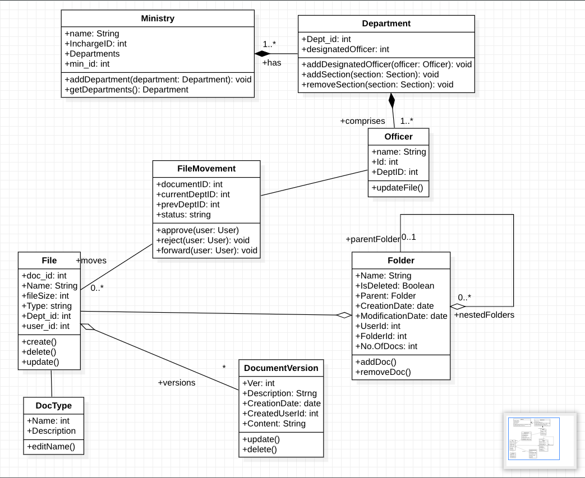

Ministry: Represents the Ministry entity. It has a name and consists of multiple departments.

Department: Represents a department within the Ministry. It has a name and consists of multiple sections. It also maintains a list of designated officers assigned to the department

File: Represents the movement of a file/document. It includes the document being processed, the current and previous locations (users), and the status of the file movement. It provides methods to approve, reject, and forward the file.

User ID: Represents a user in the system. It has a username and password for authentication purposes. It can have multiple user roles assigned to it.

Officer: Represents an officer within a department. It has a name and email address.

Document: Represents a document. It has an ID, content, and can have multiple attachments.

Folder: Represents a folder of files. It has a name , ID, number of files and other attributes and operations within it.

# Chapter 4: State diagrams

# 

### Top Diagram: Main Workflow

1. **Idle State**:
   * This is the initial state where the system waits for an action to be taken.
2. **DocumentUploading**:
   * Transition: The system moves to this state from Idle when a document is being uploaded.
   * Action: do/uploadDocument indicates that the action of uploading a document occurs here.
3. **Processing: DocumentProcessing**:
   * After uploading, the document enters the processing state.
   * This state has a sub-state machine, which is expanded in the second diagram.
4. **ArchiveDocument**:
   * Once processing is complete, the system transitions to the ArchiveDocument state where the document is archived.
5. **Final State**:
   * The filled circle indicates the end of the workflow.

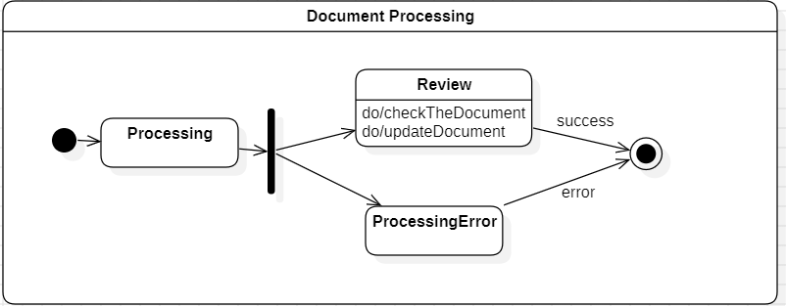

• **States**:

* **Processing**: Initial state within the "DocumentProcessing" composite state.
* **Review**: State where the document is being reviewed. Activities include "do/checkTheDocument" and "do/updateDocument".
* **ProcessingError**: State indicating an error occurred during processing.

• **Transitions**:

* From **Processing** to **Review**: Represents the transition when the document moves from general processing to the review stage.
* From **Review** to **Success** (black dot within a circle): Represents the successful completion of the document review.
* From **Review** to **ProcessingError**: Represents a transition when an error is detected during the review.
* From **ProcessingError** to **End** (black dot within a circle): Represents the final state if an error occurs.

• **Fork**:

* The black vertical bar indicates a decision point where the process can branch into different states based on conditions (i.e., successful review or error).

# Chapter 5: Interaction Modeling

## USE CASE DIAGRAM

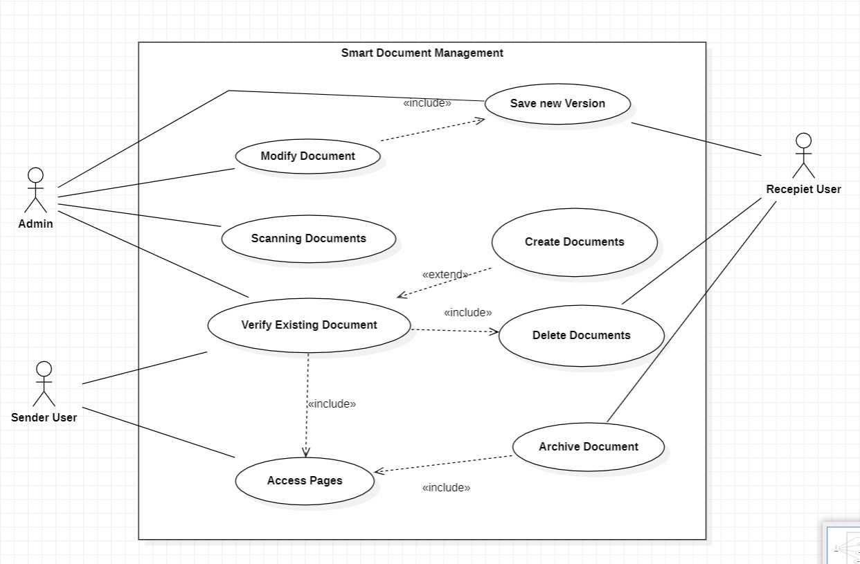

### ACTORS:

* Admin: person who is managing the system
* Sender User: user that sends, verifies and can access the documents
* Recipient User:

### USE CASES:

* Create Document : use to create a document
* Verify existing Document: documents that are already tee, it verifies
* Delete Document : removes the document
* Archive Document: archives the existing document
* Access Pages:
* Modify New Document:
* Save New Version
* Scanning Document

## SEQUENCE DIAGRAM

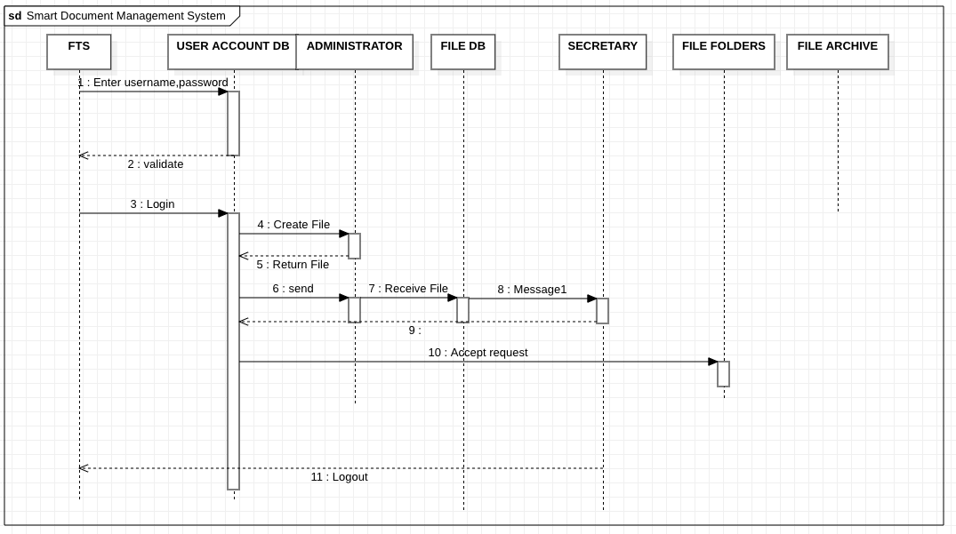

FTS : File transfer system, user logs in with his ID & password. gets validation from the user account database if it matches successfully.

USER ACCOUNT DB : Database for storing users and their account details. validates user data and keeps a check on the security of the system.

ADMINISTRATOR : has access to create and delete files. files can only be created by the administrator.

FILE DB : database for storing all the files. it is managed by the secretary and the admin only.

FILE FOLDERS : manages the file hierarchy and structure of files.

FILE ARCHIVE : stores the file that are no longer in use or are not accessed frequently.

## ACTIVITY DIAGRAM

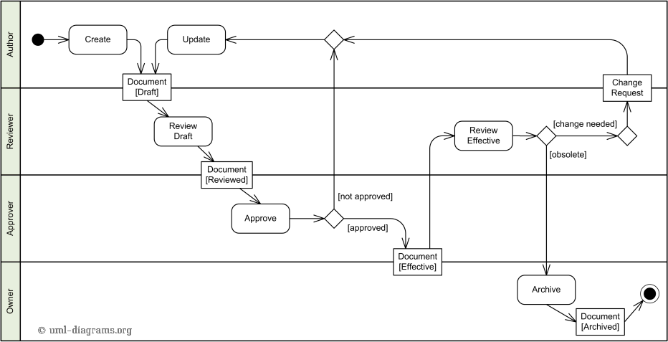

* The document is first created by the user.
* Then it goes on for a review to the reviewer
* After it is reviewed it goes on to the approver
* If it is not approved it goes back to the author for updation of contents.
* If the review is not found effective it requests the author to change.
* The workflow stays constant.

# REFERENCES

* <https://www.methodsandtools.com/tools/staruml.php>
* [https://www.softwareideas.net/a/458/dms--document-management-system-project-diagra](https://www.softwareideas.net/a/458/dms--document-management-system-project-diagrams-) [ms-](https://www.softwareideas.net/a/458/dms--document-management-system-project-diagrams-)
* <https://docs.staruml.io/working-with-uml-diagrams/sequence-diagram>
* [https://swi.cs.vsb.cz/RUPLarge/core.base_rup/guidances/guidelines/sequence_diagram_](https://swi.cs.vsb.cz/RUPLarge/core.base_rup/guidances/guidelines/sequence_diagram_AFA76EBB.html) [AFA76EBB.html](https://swi.cs.vsb.cz/RUPLarge/core.base_rup/guidances/guidelines/sequence_diagram_AFA76EBB.html)